[1]

Conceptualization and Manufacture of HypoSmooth: boat hull cleaning robot

Thomas Regis, Anthony Satragno

*Abstract*— This article describes the conceptualization and manufacture, from the initial idea to the completion of the first prototype of the Hyposmooth boat hull cleaning robot. The purpose of the first prototype inspired by the KeelCrab robot [1] is to fulfill the function of moving the final robot, as well as to verify the efficiency of the transmission system developed. Going through the design of the structure, the motorization, and the computer code that controls this system, this article takes up the essential points covered and the construction stages through which we went to arrive at our first prototype.

*Index Terms*— *Automatic Cleaning, Boat Hull, Autonomous Robotics, Prototype*

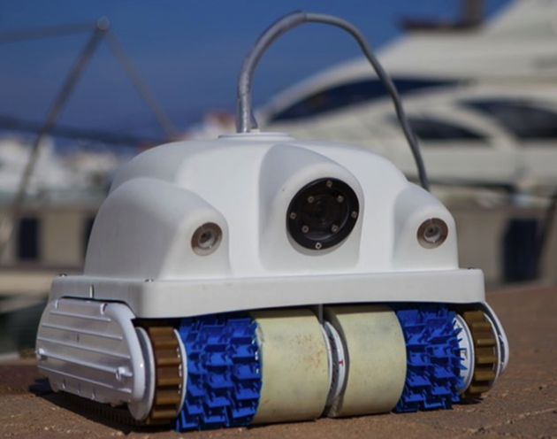

Fig 1. keelcrab robot, basic inspiration for Hyposmooth [1]

# INTRODUCTION

In some areas, automating tasks can be very useful and profitable financially and in time. This is for example the case for the nautical field, and in particular the cleaning of boat hulls. This article describes the conceptualization and manufacture, from the initial idea to the completion of the first prototype, of the Hyposmooth boat hull cleaning robot. The purpose of this robot is to effectively and autonomously clean a standard boat hull on a monthly basis in order to avoid the formation of biofilm and shells. This is to avoid labor costs or getting the boat out of the water. Indeed, the smooth character of the hull of the boat allows considerable fuel savings due to its hydrodynamics.

For this, we were inspired by a structure common to most swimming pool robots [2], as well as the KeelCrab robot [1] (fig.1) for the motorization and cleaning of the hull.

Indeed, the robot must be able to move in all directions while remaining glued to the hull of the boat by suction. The friction of the brushes on the hull as well as their composition must be adapted so as not to damage the antifouling of the boat.

We decided to take care of the movement and location in space part first, because it is the primary function that the robot must perform before tackling cleaning and submergibility.

# movement mechanism development

## Motorization

The motorization of the robot is broken down into two movements: suction and displacement.

For suction, this is done by a waterproof motor at high rotation speed driving a suitable propeller (fig.2) (the same as pool robots) continuously.

For the movement, we have chosen two motors with a low rotation speed and a large torque adapted to the force that will be required of it. These two motors will be fixed in two blocks on the chassis in order to drive a belt responsible for the transmission.

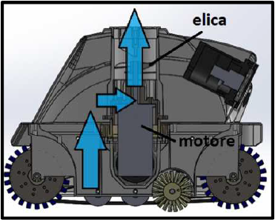Fig 2. Sectional view of a classic pool robot

## chassis and transmission

The robot uses a caterpillar system acting as a belt similar to this one:

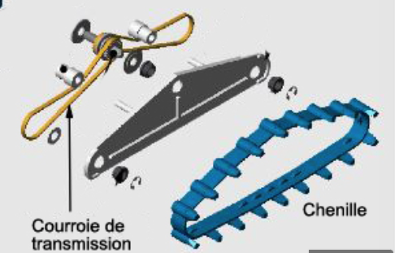

Fig 2. Exemple of caterpillar system

It is important to note that the caterpillar is not responsible for the movement but only for help in overcoming obstacles. The movement takes place by slipping of the cleaning brushes on the moving surface (here the robot shell).

It was therefore necessary to find a way to transfer the rotation of the motor to the brushes via the belt (fig.3). This transmission is carried out using a sprocket system driven by the motor and two bearings connected to the brushes on each side. It was necessary to calculate the ratios of each bearing in order to drive the belt correctly and for it to be taut [3]. Thus the front and rear brushes are integral. Each left and right part are independent of each other.

Each bearing is fixed on an axis around a ball bearing in order to reduce as much as possible each friction.

The brushes supposed to clean and ensure the movement of the robot are made of silicone. The first solution considered for their design was 3D printing in flex materials, but they were finally cast in 3D printed molds.

The chassis forms a solid and non-deformable base allowing to place the mechanical or electronic parts which must remain fixed in relation to it. It is composed of two trays firmly connected to each other by a piece of wood. On the top plate are screwed the stators of the motors as well as the various sensors and electronic components allowing the automation of the prototype. On the plate are screwed other components secondary to operation. The sprocket, front bearing and rear bearing parts need to remain equidistant when moving the robot.

Lattices (left and right) laser-cut in plexiglass, connected to the chassis of the prototype will create this unity between these three parts. They are fixed to the chassis by two screws, and they also accommodate the rotation axes of the front and rear bearings, themselves glued for more support.

Fig 3. Hyposmooth's current structure

## Computer code and Camera

The Boat Hull Cleaning Robot composed of the mechanical parts introduced above form a united system that must be able to move fully automatically on a flat curvilinear boat hull.

To ensure automated movement, the robot is equipped with a front camera responsible for capturing images of the external environment. These images are then processed by an artificial intelligence system specialized in image recognition, running on a mini-computer. This computer program, previously trained through deep learning, deduces the direction in which the robot should move based on the captured image. This information is then sent to the Arduino board, which is responsible for controlling the various mechanical parts of the prototype.

The Arduino computer system which, thanks to its intuitive interface, makes it possible to code the different functions that the robot performs. The mechanical energy to move the prototype cleaner is provided by the two motors presented above.

Fig 4. Hyposmooth's camera in its casing

The computer codes comprising all the functions necessary for the movement of the robot are indexed in the same file and operate simultaneously so that the robot can fulfill its mobility objective as well as be able to react and adapt to external disturbances. The different mechanical parts of the prototype are controlled by the Arduino computer system which, thanks to its intuitive interface, makes it possible to code the different functions that the robot performs. The mechanical energy to move the prototype cleaner is provided by the two motors presented above.

These two motors are controlled by the Arduino system from four functions. 1 – Both motors run (Robot moves forward) 2 – Right motor only runs (Robot runs right) 3 – Left motor only runs (Robot runs right) 4 – Both motors stop ( The robot stops). The robot is able to adapt to the presence of bulky objects that may be present on the hull. The ultrasonic sensor works with a code to calculate the distance at which there is a residue preventing complete cleaning of the hull.

The automation of the robot is possible thanks to an accelerometer which is sensitive to the acceleration according to the three terrestrial axes noted X, Y and Z. The calculation of position and length is carried out thanks to the digital sampling of time as well as to the differential equations relating the position, velocity, and acceleration of a kinematic object.

# CONCLUSION

To conclude, the current prototype fulfills the specifications concerning the movement. The motors move the brushes thanks to the transmission system and the robot moves while cleaning thanks to the orders of the camera and the Nvidia card. The structure is now robust, and each part has been perfectly assembled. With the task of moving and tracking in space now complete, future projects will concern the waterproofing of the robot and its testing in an aquatic environment.

References

1. http://www.keelcrab.fr/
2. https://www.meseo.fr/piscine/fonctionnement-robot-piscine/#:~:text=Un%20robot%20piscine%20%C3%A9lectrique%20est,brosse%20nettoyante%20sur%20sa%20base.http://mathenjeans.free.fr/amej/edition/0101engr/01daeng1.html#:~:text=Par%20d%C3%A9finition%2C%20le%20rapport%20d,nombre%20de%20dents%20des%20roues.B. Smith, “An approach to graphs of linear forms (Unpublished work style),” unpublished.
3. http://mathenjeans.free.fr/amej/edition/0101engr/01daeng1.html#:~:text=Par%20d%C3%A9finition%2C%20le%20rapport%20d,nombre%20de%20dents%20des%20roues.

Biography

Student Anthony Satragno, completed a scientific high school cycle before doing a preparatory class at the Louis Barthou high school, is now at the Polytech Nice-sophia school in the robotics section.

Student Thomas Regis, completed a scientific high school cycle before doing a preparatory class at the Montaigne high school, is now at the Polytech Nice-sophia school in the robotics section.

1. Student SATRAGNO Anthony is with Université cote d’Azur Polytech Nice-Sophia, 930 rte des colles 06410 Biot, (e-mail: anthony.satragno@etu.unice.fr)

   Student REGIS Thomas is with Université cote d’Azur Polytech Nice-Sophia, 930 rte des colles 06410 Biot, (e-mail: thomas.regis@etu.unice.fr)